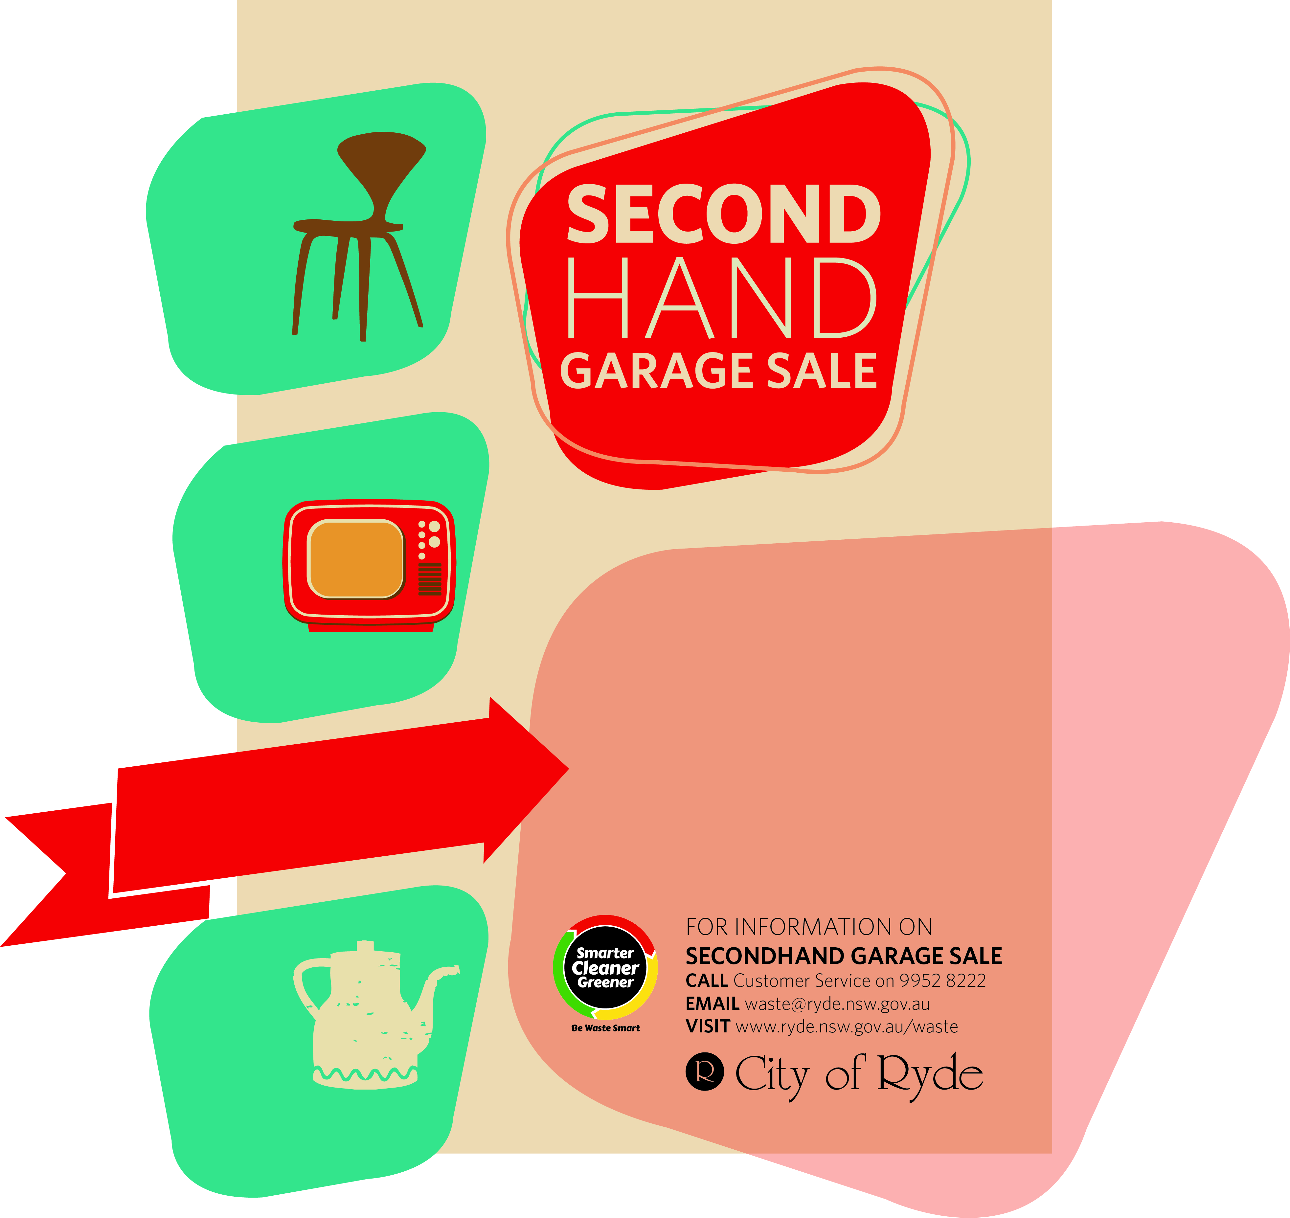

Day Month 2015

# Street Name,

Suburb