Revision 4
Owner: Tenders & Contracts



SECTION 5
RETURNABLE SCHEDULES

Expression of Interest
Westward Cottage
at 8 Turner Street, Ryde, 2112

COR-EOI-01/16

Closing Date

2PM Wednesday 17 August 2016

Site Visit
10:00am to 12:00 PM Tuesday, 19 July 2016

SECTION 5 - RETURNABLE SCHEDULES

The following schedules must be completed as part of the request for Expression of Interest submission for Westward Cottage:

Schedule | Description | Page
Schedule 1 | Organisation details and background | 3
Schedule 2 | Nominated Persons | 4
Schedule 3 | Proposed programs and services | 5
Schedule 4 | Experience in and ability, capacity and approach towards building maintenance and its coordination | 6
Schedule 5 | Funding and strategic commitment to the Ryde Local Government Area and to addressing local community needs | 7
Schedule 6 | Workplace Health & Safety and Rehabilitation | 8
Schedule 7 | Insurances | 9
Schedule 8 | Statutory Declaration | 10
Schedule 9 | Community Building Licensing Policy Assessment | 12
Schedule 10 | Acknowledgement of Addenda and Notices | 13

SCHEDULE 1: ORGANISATION DETAILS AND BACKGROUND

Organisation details
Name
Address
Legal Entity
ABN
Phone Number
Mobile Number
Email
Website
Current program and services in Ryde

Organisation Background
Brief history of organisation
Details of corporate/ governance structure
Number of full-time, part-time and casual staff employed
Number of volunteers
Client base in the Ryde LGA
Your involvement in partnerships between NGOs, Council, Government
Accessibility – Clients from CALD and ATSI backgrounds
Accessibility –Clients with low income

SCHEDULE 2: NOMINATED PERSONS

Nominated person details
Name
Official Position Held
Address
Phone Number
Mobile Number
Email

Nominated person details
Name
Official Position Held
Address
Phone Number
Mobile Number
Email

SCHEDULE 3: PROPOSED SERVICES

Please describe the services and activities that you want to deliver
Key programs, services and activities to be delivered
Potential areas of programming growth for your organisation

Please comment on how your proposed programs and services will contribute to addressing the following
Community needs in Ryde LGA
Community interests in Ryde LGA

Your space requirements
Intended days and hours of operation
Number of full-time, part-time and volunteer staff to be accommodated
Rooms/space needed for ongoing exclusive use. Please describe the nature of use.
Rooms/space needed for ongoing shared use. Please describe the nature of use.
Special requirements
Are you interested in co-location with other organisations?
If you are interested in co-location, then what kind of organisations would like to co-locate with?
SCHEDULE 4: EXPERIENCE IN AND ABILITY, CAPACITY AND APPROACH TOWARDS BUILDING MAINTAINENCE AND ITS COORDINATION

Please describe your organisations experience in and ability, capacity and approach towards the following conditions of service
Coordination of staffing and operations

Coordination of maintenance and utilities

Coordination of site compliance

Coordination of payment and administration

SCHEDULE 5: FUNDING AND STRATEGIC COMMITMENT TO THE RYDE LOCAL GOVERNMENT AREA

Overall financial capacity to contribute

Government funding p.a.
Fundraising p.a.
Fees p.a
Assets

Your organisation delivers services to how may Local Government Areas?
Ryde
Evidence of existing and potential funding
Funding source | Services/ programs funded | Funding amount | Funding period

Evidence of commitment to providing services in the Ryde Local Government Area
SCHEDULE 6: WORKPLACE HEALTH & SAFETY AND REHABILITATION

Demonstrate commitment to Workplace Health & Safety and Rehabilitation (WHS&R) and understanding and acceptance of the principles of WHS.

 | SUBJECT | YES  ✓ | NO  X
1. | Does the organisation have a WHS&R Management Plan as part of its overall management system?  (If yes give details)
Is the WHS&R Management Plan accredited by a NSW Government agency or an accredited third party?
(If yes give details)
2. | Has WorkCover NSW issued the organisation with any Prohibition Notices, Improvement Notices or fines in the past 12 months?  (If yes give details)
3. | Is the organisation able to provide documented evidence that within its organisation, there are people or resources nominated to:
 | - Define WHS&R management policies and objectives, priorities and targets;
 | - Define the responsibilities of personnel for WHS&R matters;
 | - Identify system verification requirements and allocating human, technical and financial resources adequate to meet those requirements;
 | - Ensure compliance with WHS&R legislation and regulations;
 | - Keep abreast of changes in legislation and regulations;
 | - Acquire and disseminate WHS&R management information;
 | - Plan and conduct training in WHS&R management, including inducting new employees;
 | - Oversee the development and implementation of WHS&R procedures;
 | - Assess subcontractors' and suppliers' abilities to comply with WHS&R requirements;
 | - Ensure compliance with safe work practices and procedures.

SCHEDULE 7: INSURANCES

The following insurances will be required and shall state details of current policies for these insurances.

WORKERS COMPENSATION OR PERSONAL ACCIDENT AND ILLNESS INSURANCE:

Insurance against any death of or injury to persons employed by the Service Provider as required by the Workers Compensation Act 1987.

ALTERNATIVELY: Where the Service Provider has no employees and in lieu of Workers Compensation Insurance, insurance for personal accident and illness under a policy.

Insurance Company: | Amount of coverage: |  | As detailed above |  | Yes ✓ | No X
 | Policy Number: |  |  | Expiry Date:

PUBLIC LIABILITY INSURANCE

Insurance against the death or injury to any third party or parties or loss of or damage to any property including loss of use of property whether it is damaged or not whatsoever caused during the course of the contract. The policy shall have a limit of indemnity of not less than the amount indicated for any one occurrence, but shall be unlimited in the aggregate.

Insurance Company: | Amount of coverage: |  | Not less than $20 million |  | Yes ✓ | No X
 | Policy Number: |  |  | Expiry Date:

SCHEDULE 8: STATUTORY DECLARATION

I, ..................................................................................................... [insert name]

of............................................................................................................ [address]

a director/authorised officer of ................................................. [compa
ny name]

(ACN............................................) (ABN............................................) ("Respondent")

do solemnly and sincerely declare as follows:-
- that I am authorised by the Respondent to make this declaration:
- and I hereby declare that:

The Respondent wishes to provide a submission on the basis of the Response annexed to this Statutory Declaration and submitted in accordance with the Request for Expression of Interest (EOI).

- The Response to which this statutory declaration is appended has not been prepared with the benefit of:
- information obtained from a current or former officer or employee of the City of Ryde
- information otherwise improperly obtained from City of Ryde or any department or agency of the State

- The Respondent is aware that giving false or misleading information is a serious offence

- The Respondent through its officers, employees or agents, has/have not attempted and will not attempt, to influence improperly any officer or employee of City of Ryde in connection with the EOI process.

- The Respondent understands and agrees to all conditions including without limitation obligations and acknowledgments included in the EOI.

- The Respondent hereby:

Consents to and authorises the City of Ryde, its officers , employees, agents or advisers to seek any information, including financial information, required for the purpose of the EOI; and
  - agrees to provide at the Respondent's expense reasonable assistance to City of Ryde to assist it in any checking it wishes to have undertaken under or in respect of the EOI.

I make this solemn declaration by virtue of the Statutory Declarations Act 1959 and subject to the penalties provided by that Act for the making of false statements in statutory declarations, conscientiously believing the statements contained in this declaration to be true in every particular.

............................................................................................................................... (1)

Declared at .................................... the .............. day of ..................................... 20....., before me

.............................................................................................................................. (2)

Notes: (1) Signature of the person making the declaration.
(2) Signature and title of the person before whom the declaration is made.

SCHEDULE 9: COMMUNITY BUILDING LICENSING CATEGORY ASSESSMENT

Complete the assessment below by identifying your organisations status against each criteria (eg Government Fundraising p.a., assets, capital investment) and then write in the assessment column the corresponding point number. Add up the total points at the end of the table.

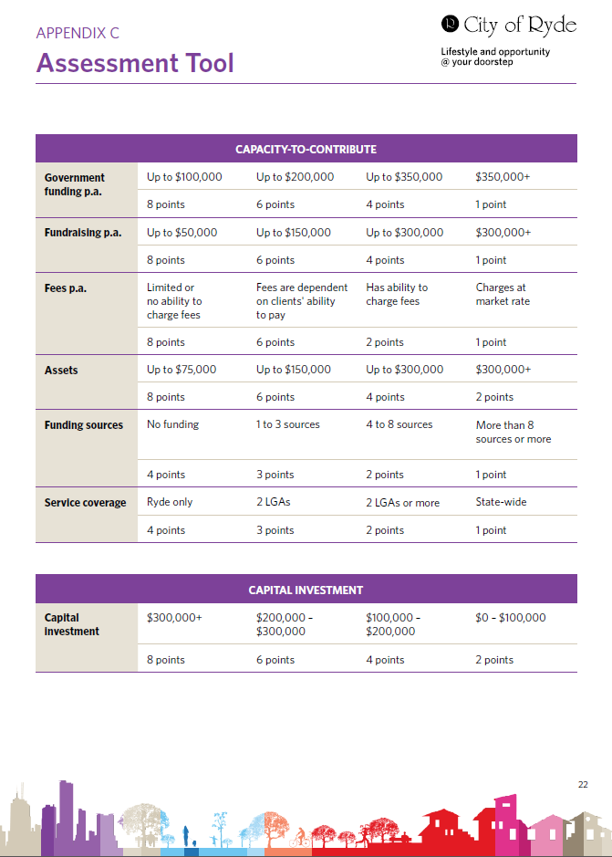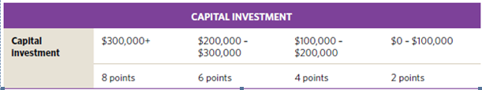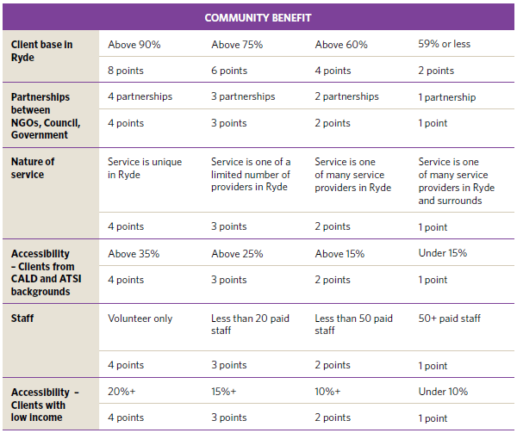
Assessment
Total
Points
Licensing Category

Select the category you feel you fall under based on your assessment above. Please note that this assessment will be reviewed by Council and could change as a result of that review.

67 – 76 Point Category 1 | 31 – 46 Points Category 4
57 – 66 points Category 2 | 15 – 30 Points Category 5
47 – 56 Points Category 3

SCHEDULE 10: ACKNOWLEDGEMENT OF ADDENDA & NOTICES

I / We, ……………………………………… [insert full name of Respondent], acknowledge receipt of the following:

[Respondents must fully describe all documents including addenda, and any notices, which are issued by the City of Ryde]

