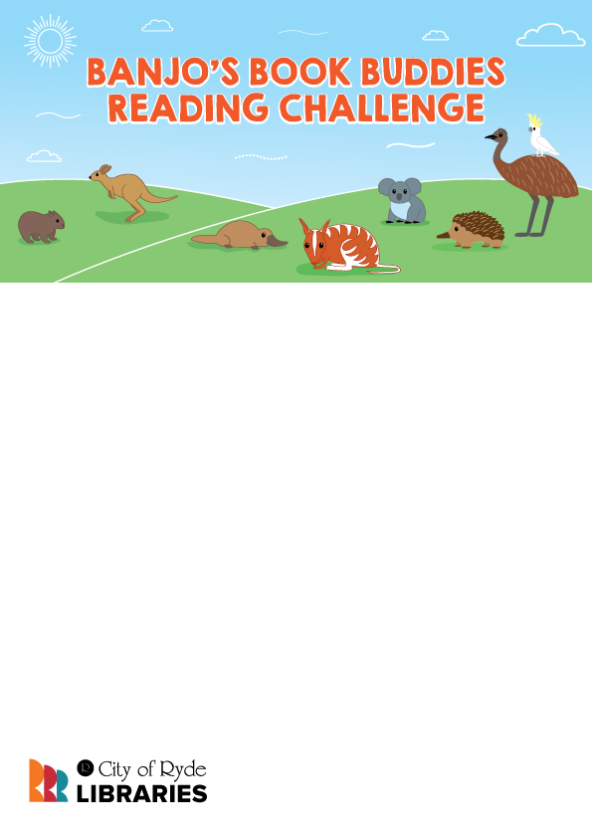

Certificate of completion   
awarded to

**ENTER NAME HERE**

Month 2021

For successfully completing Banjo’s Book Buddies Reading Challenge.

Congratulations!